Sari-Sari Store Management System
Database Design and Implementation Documentation

1. Project Overview
Project Description
The Sari-Sari Store Management System is a database-driven application designed to help small store owners manage:
- Product inventory
- Sales transactions
- Customer debts (Utang)
- Supplier purchases
- Operating expenses
The system aims to replace manual record-keeping with a structured and reliable database solution.

Business Rules
Sales
- Products can be sold through Cash Sale or Utang Sale.
- Stock quantity is automatically reduced after a successful sale.
Customer Debt
- Debt records are automatically created when an Utang Sale is completed.
- Partial payments are not allowed.
- Customers with active unpaid debt cannot create another debt.
- Only one active debt is allowed per customer.
- Debt must be fully paid before another debt can be created.

Inventory
- Products must have unique names.
- Stock quantity cannot become negative.
- Purchases increase inventory levels.
- Sales decrease inventory levels.
2. Entity Relationship Diagram (ERD)
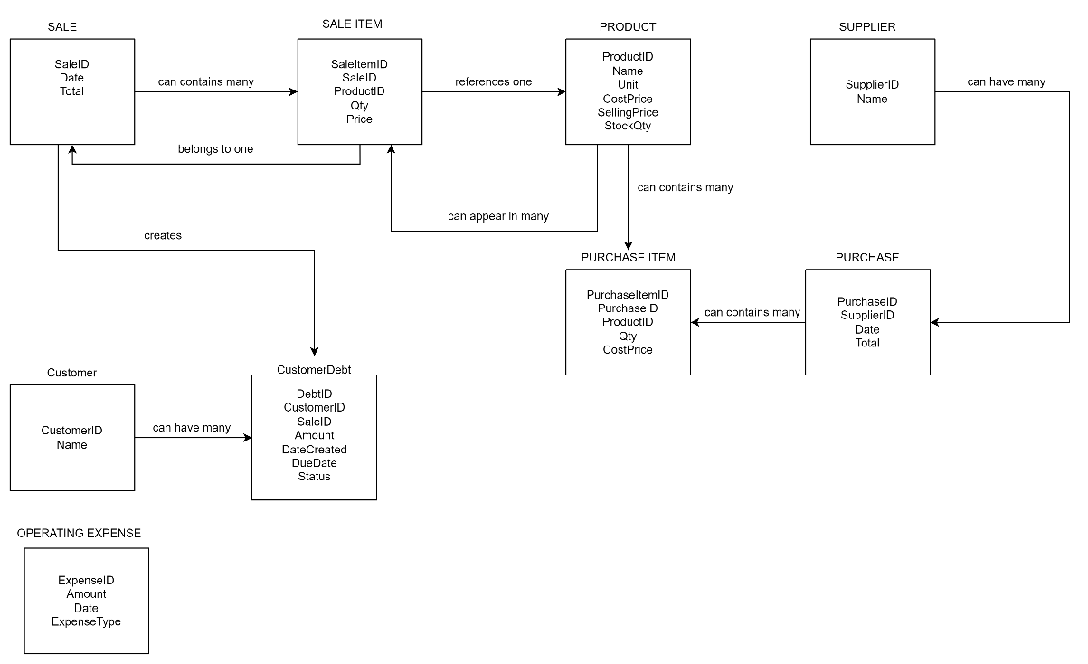
Main Entities
- Product
- Supplier
- Purchase
- Purchase_Item
- Sale
- Sale_Item
- Customer
- Customer_Debt
- Operating_Expense
3. System Flowchart
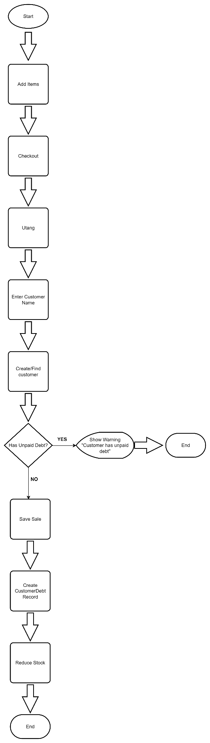
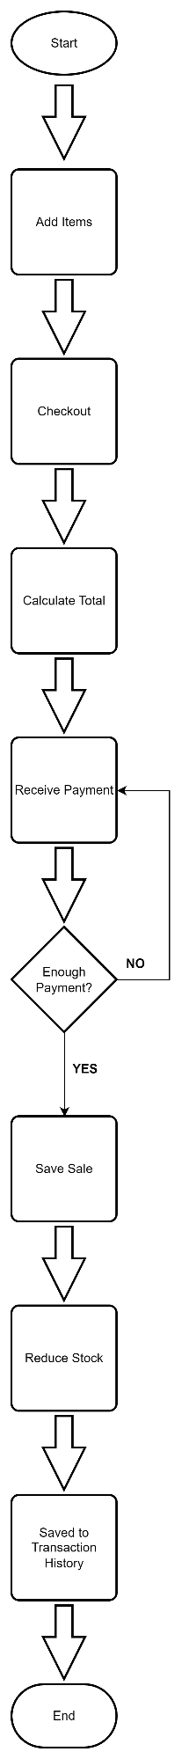
Normal Sale Process Utang Sale Process Debt Payment Process
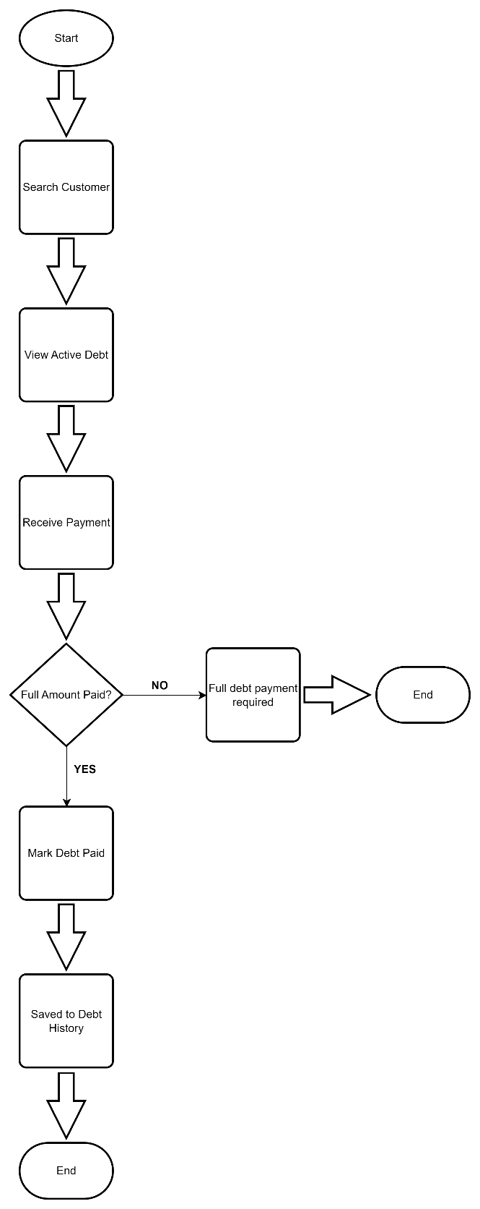

Main Processes
Inventory Management
Add Product
→ Update Product
→ Purchase Stock
→ Inventory Updated
Cash Sale
Select Products
→ Checkout
→ Receive Payment
→ Create Sale
→ Update Inventory
Utang Sale
Select Products
→ Checkout
→ Utang Sale
→ Select/Create Customer
→ Create Sale
→ Create Customer Debt
→ Update Inventory
Debt Payment
Select Customer Debt
→ Receive Full Payment
→ Mark Debt as Paid

4. Database Schema
Database Name:
sari_sari_store_db
Tables:
• Product
• Supplier
• Customer
• Sale
• Sale_Item
• Purchase
• Purchase_Item
• Customer_Debt
• Operating_Expense
Views:
• vw_active_customer_debt
• vw_inventory_status
• vw_sales_summary
• vw_sale_details
• vw_profit_report
Stored Procedures:
• CreateCashSale
• CreateUtangSale
•CheckCustomerDebt
•PayCustomerDebt
•CreatePurchase
Triggers:
• before_create_debt
• after_sale_item_insert
• after_purchase_item_insert
• before_debt_status
5. Data Dictionary
PRODUCT
Field | Data Type | Key | Description
ProductID | INT | PK | Unique Product ID
Name | VARCHAR(100) | UNIQUE | Product Name
Unit | VARCHAR(20) |  | Piece, Pack, Bottle
CostPrice | DECIMAL(10,2) |  | Purchase Cost
SellingPrice | DECIMAL(10,2) |  | Selling Price
StockQty | INT |  | Current Inventory

SUPPLIER
Field | Data Type | Key
SupplierID | INT | PK
Name | VARCHAR(100)

PURCHASE
Field | Data Type | Key
PurchaseID | INT | PK
SupplierID | INT | FK
PurchaseDate | DATETIME
Total | DECIMAL(10,2)

PURCHASE_ITEM
Field | Data Type | Key
PurchaseItemID | INT | PK
PurchaseID | INT | FK
ProductID | INT | FK
Qty | INT
CostPrice | DECIMAL(10,2)

SALE
Field | Data Type | Key
SaleID | INT | PK
SaleDate | DATETIME
Total | DECIMAL(10,2)

SALE_ITEM
Field | Data Type | Key
SaleItemID | INT | PK
SaleID | INT | FK
ProductID | INT | FK
Qty | INT
Price | DECIMAL(10,2)

CUSTOMER
Field | Data Type | Key
CustomerID | INT | PK
Name | VARCHAR(100) | UNIQUE
Notes
- Customers are created only for Utang transactions.
- No customer analytics are included.
- No loyalty program is implemented.

CUSTOMER_DEBT
Field | Data Type | Key
DebtID | INT | PK
CustomerID | INT | FK
SaleID | INT | FK
Amount | DECIMAL(10,2)
DateCreated | DATETIME
DueDate | DATE
Status | VARCHAR(20)

OPERATING_EXPENSE
Field | Data Type | Key
ExpenseID | INT | PK
Amount | DECIMAL(10,2)
ExpenseDate | DATETIME
ExpenseType | VARCHAR(50)

6. Relationship Summary
Parent | Child | Relationship
Sale | Sale_Item | 1:M
Product | Sale_Item | 1:M
Supplier | Purchase | 1:M
Purchase | Purchase_Item | 1:M
Product | Purchase_Item | 1:M
Customer | Customer_Debt | 1:M
Sale | Customer_Debt | 1:1

7. SQL Objects
Tables
- Product
- Supplier
- Purchase
- Purchase_Item
- Sale
- Sale_Item
- Customer
- Customer_Debt
- Operating_Expense

Constraints
Unique Constraints
Product.Name
Customer.Name
Foreign Keys
Sale_Item → Sale
Sale_Item → Product
Purchase → Supplier
Purchase_Item → Purchase
Purchase_Item → Product
Customer_Debt → Customer
Customer_Debt → Sale

Views
vw_CurrentInventory
Displays all products and current stock.
vw_ActiveDebts
Displays customers with active unpaid debt.
vw_DailySales
Displays daily sales totals.

vw_LowStockProducts
Displays products below reorder threshold.

Stored Procedures
CreateCashSale
Creates a cash sale transaction.
CreateUtangSale
Creates an utang sale transaction and automatically creates customer debt.
PayCustomerDebt
Marks customer debt as paid.
CreatePurchase
Creates purchase transaction and updates inventory.

Triggers
before_create_debt
Prevent customer from creating a new debt when an active debt already exists.
after_sale_item_insert
Automatically reduce stock after sale.
after_purchase_item_insert
Automatically increase stock after purchase.
before_debt_status
Automatically set Status = 'Active' if no status is supplied.
before_sale_item_insert
Prevent sales that would create negative inventory.

8. Test Cases
Test Case 1
Create Cash Sale
Expected Result:
- Sale created successfully
- Inventory reduced
Status:
PASS

Test Case 2
Create Utang Sale
Expected Result:
- Sale created
- Customer debt created
Status:
PASS

Test Case 3
Attempt Second Debt With Existing Active Debt
Expected Result:
- Transaction rejected
Status:
PASS

Test Case 4
Pay Customer Debt
Expected Result:
- Debt marked Paid
Status:
PASS

Test Case 5
New Debt after Payment
Expected Result:
- Can create new debt with the same customer after payment
Status:
PASS

Test Case 6
Purchase Restocking
Expected Result:
- Add new Stock to current Stock
Status:
PASS

Test Case 7
Attempt Negative Inventory
Expected Result:
- Transaction blocked
Status:
PASS

9. Future Improvements
- Barcode support
- Receipt printing
- Multiple store branches
- User authentication and roles
- Dashboard analytics
- Sales reporting
- Mobile application integration

10. Technical Skills Demonstrated
Database Design
- ERD Modeling
- Normalization
- Data Dictionary Creation
SQL Development
- DDL
- DML
- Constraints
- Views
- Stored Procedures
- Triggers
Software Engineering
- Business Rule Analysis
- Process Flow Design
- Database Documentation
- Test Case Design

11. Folder Structure
SariSariStoreDB/
│
├── docs/
│ ├── ERD.png
│ ├── Flowchart.png
│ └── Documentation.docx
│
├── sql/
│ ├── 01_create_database.sql
│ ├── 02_create_tables.sql
│ ├── 03_constraints.sql
│ ├── 04_views.sql
│ ├── 05_stored_procedures.sql
│ ├── 06_triggers.sql
│ └── 07_test_cases.sql
│
└── README.md

